
Recommendations for AEF changes
Draft – v0.5.1

Dear registry system administrators and technical experts,
We kindly request your input on this document.
Please send your feedback to a6rsaf@unfccc.int

Contents
Page
I. Introduction 4
A. Mandate 4
B. Applicability 4
C. Objectives 4
D. Scope 4
E. Derived documents 5
F. Key words 5
G. Graphical notation for figures 6
H. Future collaborative development 6
II. Guiding principles 7
III. Processes 10
A. The scope of these standards in the lifecycle of Mitigation Outcomes and ITMOs 10
B. Transactions 12
C. Announcement of modification of ITMOs attributes 21
D. Pulling and viewing holdings and transaction history of ITMOs 22
E. Account management 23
F. Reconciliation management 24
G. Registry management 25
H. Data export 26
I. Textual message 27
IV. Technical requirements 28
A. Time synchronization 28
B. Timeouts and maximum payload size 28
C. Security 28
D. Sandbox testing environment 29
E. Consolidated system 30
F. Internationalization 30
G. Data retention and preservation 30
H. API standard and lifecycle management 30
Annex I – Attributes of ITMOs 32
Annex II – Attributes of transactions 34
Annex III – Transaction validations 36
I. Mandatory validations 36
II. Configurable validations 36
III. Valid transactions 38
Annex IV – Account types 40
Annex V – Definitions 42

Abbreviations and acronyms

AEF Agreed electronic format
AES Advanced Encryption Standard
API Application Programming Interface
CARP Centralized Accounting and Reporting Platform
CMA Conference of the Parties serving as the meeting of the Parties to the Paris Agreement
CSV Comma-Separated Values
ECDHE Elliptic Curve Diffie-Hellman Ephemeral
ECDSA Elliptic Curve Digital Signature Algorithm
GNU GNU’s not Unix
GZIP GNU zip
HTTP Hypertext transfer protocol
IEEE Institute of Electrical and Electronics Engineers
IP Internet Protocol
ISO International Organization for Standardization
ITMO Internationally Transferred Mitigation Outcomes
JPG Joint Photographic Experts Group
JSON JavaScript Object Notation
MB Megabyte
MIME Multipurpose Internet Mail Extensions
NDC Nationally Determined Contribution
PDF Portable Document Format
PEM Privacy-Enhanced Mail
PNG Portable Network Graphics
POSIX Portable Operating System Interface
REST Representational State Transfer
RFC Request for Comments
RSA Registry Systems Administrators
SHA Secure Hash Algorithms
TAR Tape Archive
TLS Transport Layer Security
UML Unified Modeling Language
UTC Coordinated Universal Time

- Introduction
  - Background
          - Decision <> require Parties to submit Annual Information in an “agreed electronic format” (AEF). This format is in the form of a Microsoft Excel workbook, with worksheets for Submission information, Authorizations, Actions, Holdings, and Authorized Entities.
          - However, the format of the originally provided AEF Template, and inconsistent use of the template by Parties have led to initial submissions that cannot be fully verified, both by humans, and electronic tools.
          - An automatic syntax checking tool, “AEFSyntax” has been developed to verify the syntax of AEF submissions. This tool is written in Python, and relies on the “openpyxl” library to read and write Microsoft Excel workbooks.
          - The AEFSyntax tool checks
            - The structure of the AEF Submission:
              - the sheet count, and sheets names correspond to those in the template, and
              - the field count, and field names in each sheet correspond to those in the template.
            - The content of each data cell in each sheet:
              - If the field is mandatory, that it is filled in, and not filled in with “NA” or “not applicable”
              - If the field is an integer, it is a valid integer (no punctuation, no alpha, no spaces.
              - If the field is a number, it is a valid number (integer with decimal point).
              - If the field is a year, it is a four-digit integer. For example, Vintage.
              - If the field is a date, it is in the format “DD/MM/YYYY”.
              - If the field is a date-time, it is in the ISO 8601 format “<YYYY-MM-DD>T<HH:MM:ss.sss>Z”
              - If the field must conform to a specific pattern, it matches the pattern. For example some version numbers require a major and minor version number “X.Y”
              - If the field is enumerated, it is one of the valid enumerated values. For example, a Metric field must be either “GHG” or “non-GHG”
          - Note that
  - Applicability
          - These recommendations are for Partys to agree to changes to the AEF Excel template.
  - Objectives
          - These recommendations enable automated verification AEF submissions by Parties.
  - Scope
          - This document applies to the AEF template, and the data entered by participating Parties.
  - Derived documents
          - The AEF template.
  - Key words
          - The key words "MUST", "MUST NOT", "REQUIRED", "SHALL", "SHALL NOT", "SHOULD", "SHOULD NOT", "RECOMMENDED", "MAY", and "OPTIONAL" in this document are to be interpreted as described in RFC 2119.
  - Future collaborative development
          - Registry administrators are RECOMMENDED to promptly raise issues if they identify discrepancies, inconsistencies, inefficiencies, or any other problems with these standards.
          - Registry administrators SHOULD also suggest any enhancements they deem beneficial.
          - Registry administrators who are in a position to do so SHOULD actively participate in the resolution of the raised issues, as well as in the implementation of the needed improvements in these standards.
          - To facilitate the process of identifying, discussing, suggesting and integrating improvements, a collaborative environment is REQUIRED to be established. Within this environment, these standards SHALL be continuously developed, ensuring tracking of any changes and clear identification of future releases.

- Changes made to the original template

          - These standards have been elaborated following these guiding principles:
            - Robust accounting: information concerning ITMO transactions are documented and recorded accurately, and ITMO holdings, when reported, reflect the true position of a registry;
            - Avoidance of double counting: ITMOs are only located in one account at any given time and maintain strict consistency between balances of ITMOs in each account and their ledger. Real-time consistency checks are performed at the time of transaction proposal, frequent reconciliations are undertaken, and in the event of an inconsistency, a predictable process for resolving it is in place;
            - Business validations: it is up to registries to accept or reject transaction proposals, providing Parties with the flexibility to comply with their domestic rules and regulations;
            - Timeliness: all transactions and all operations adhere to strict timeframes for finalization; information can be reported promptly, and cut-off date and times are defined for the purpose of reporting;
            - Security: communications between registries are confidential, fault-resilient, reliable, and non-repudiable. A registry cannot access another Party’s transactions, notifications or any other data. No confidential information is exchanged beyond what is strictly necessary to process transactions, enable non-repudiation of transactions, and traceability of ITMOs;
            - Self-service: registry initialization and testing operations are streamlined via, by providing automated self-service options. For example, planned registry testing and data seeding, can reduce operational costs and support delivery times;
            - Low barrier of entry: the API supporting these standards enable registries to interoperate without the need to implement a server. A polling architecture dispenses with the need for registries to implement a server-side API, and its associated infrastructure (e.g. http servers, 2-way SSL). The polling architecture allows registries to be intermittently offline without endangering their tracking of ITMOs, lowering the service levels required and allowing for registries that would only perform few transactions to effectively interoperate without losing the benefits listed above;
            - Pull and view: the API supporting these standards enables registries to pull and view data and information on holdings and transaction history, consistent with para. 49 of decision 4/CMA.6.
          - These standards anticipate that interoperability between registries, that opt to apply these standards, is facilitated by an interoperability hub. The options by which these standards may be applied, each of which incorporate an interoperability hub, are depicted in Figure 1 (note that Figure 1 is purely a logical depiction, other than each subcomponent requiring an IP address, there is no implication of their implementation):
            - Option 1 – Independently provided interoperability hub
Three Parties, owning Registry 1, Registry 2, and Registry 3 respectively, wish to interoperate. They co-develop or acquire an interoperability hub, independent from any of the Parties, that implement these standards.
            - Option 2 – Independently provided consolidated registry system
Three Parties wish to interoperate. They do not currently own individual registries. They co-develop or acquire a consolidated registry system providing each Party a secure, independent, logically segregated registry section, Registry section 1, Registry section 2, Registry section 3, that interoperate with each other according to these standards, via an interoperability hub subcomponent.
            - Option 3 – Party provided externally interoperable registry system
Three Parties wish to interoperate. Party 1 develops or acquires a registry system that includes an externally interoperable hub subcomponent, and registry sections for Party registries. Party 1 uses a registry section as its own registry, and interoperates with the other Parties, that own Registry 2 and Registry 3 respectively.
            - Option 4 – Independently provided consolidated registry system with external interoperability.
An independent organisation develops or acquires a registry system that includes an externally interoperable hub subcomponent, and registry sections for Party registries. Some Parties use secure, independent, logically segregated registry sections, other Parties use externally connected registries for interoperability.
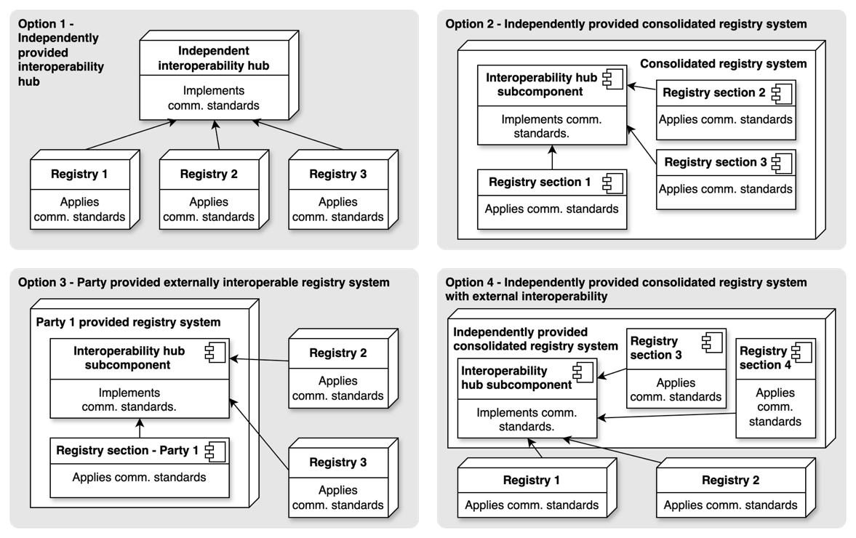
Figure 1 - Options for applying these interoperability standards

          - Each participating Party MUST submit, on an annual basis, information in an agreed electronic format (AEF) pursuant to annex, chapter IV.B of decision 2/CMA.3 through the submission portal of the CARP according to annex I, chapter II.A of decision 6/CMA.4 (as depicted in Error! Reference source not found.). The submission portal SHALL have a human- and machine-readable interface for uploading information, including for recording data in the Article 6 database pursuant to decision 6/CMA.4, annex I, chapter II.A.
          - The secretariat SHALL apply these standards to the international registry referred to in decision 2/CMA.3, annex, chapter VI.A. In implementing these standards, the secretariat:
            - Provides registry sections for Parties that do not have, or have access to a registry and/or that do not wish to establish and maintain their own registry. The international registry, including each of its registry sections, adhere to the consolidated system requirements set out in section ‎IV.E;
            - Operates an interoperability hub to facilitate communications between registries, including with the Article 6.4 mechanism registry referred to in decision 3/CMA.3, annex, para. 63, for Parties that choose not to establish and maintain a separate interoperability hub;
            - Designates the international registry administrator as the interoperability hub administrator under these standards, with the secretariat fulfilling that role.
          - Participating Parties who opt for applying the guidance in annex I, chapter I.B of decision 6/CMA.4 are REQUIRED to interoperate in the manner prescribed by these standards (registries 1, 2, 3, 8, and 9 in Error! Reference source not found.).
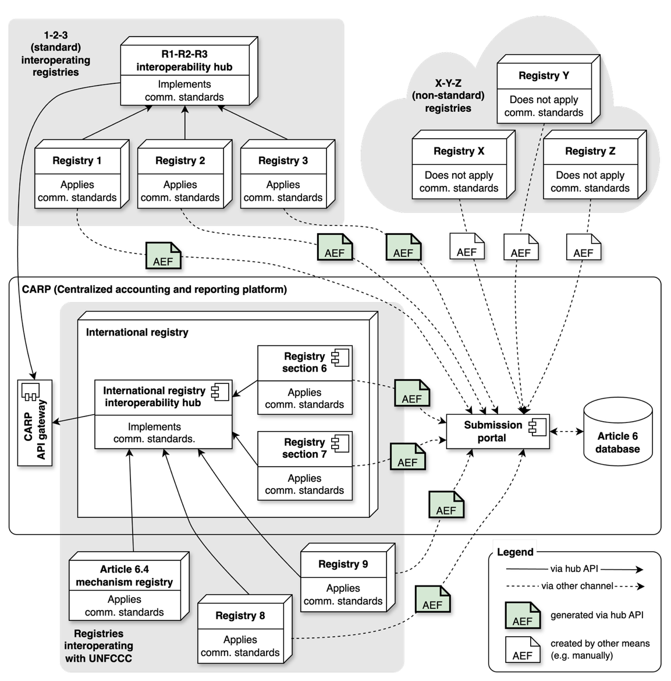
Figure 2 - Overview of different registry arrangements

          - Figure 2 depicts how different registries apply, or do not apply, these standards, and interact with UNFCCC secretariat:
            - Registries 1, 2, and 3 use Option (1) from Figure 1 above. They develop or acquire an interoperability hub that implements these standards. The interoperability hub accesses the CARP API gateway, and the Parties submit AEF reports through the CARP submission portal.
            - The UNFCCC secretariat provides the international registry that includes registry sections (registry sections 6 and 7 in Figure 2), and an interoperability hub as subcomponents. The registry sections and interoperability hub apply and implement these standards. The Article 6.4 mechanism registry SHALL apply these standards (as shown in Error! Reference source not found.), and SHALL be connected to the international registry’s interoperability hub. External registries that opt to interoperate via the international registry’s interoperability hub (registries 8 and 9 in Figure 2) are REQUIRED to apply these standards.
This is an instantiation of Option (4) of Figure 1.
            - Participating Parties that do not opt for applying the guidance of decision 6/CMA.4 MAY benefit from applying certain provisions of these standards but SHALL NOT be connected to the international registry (e.g. registries X, Y, and Z in Error! Reference source not found.).;
- Processes
  - The scope of these standards in the lifecycle of Mitigation Outcomes and ITMOs
          - Decision 6/CMA.4, paragraph 32, requires these standards to apply to transactions of ITMOs, whereas decision 2/CMA.3, annex, paragraph 29 requires registries to track authorizations and first transfers.
Consequently, these standards apply from when an authorized MO is registered with the interoperability hub, and continue to apply after the ITMO is used or cancelled, as there are restrictions on used or cancelled ITMOs.
For the purpose of these standards, the acronym MO is used, when necessary, to refer to such (pre-)ITMO, until a first transfer is effected, and the acronym ITMO thereafter.
The lifecycle of MOs and ITMOs is shown in Figure 3. The scope of these standards within this lifecycle is also depicted. The diagram is explained in the following paragraphs.
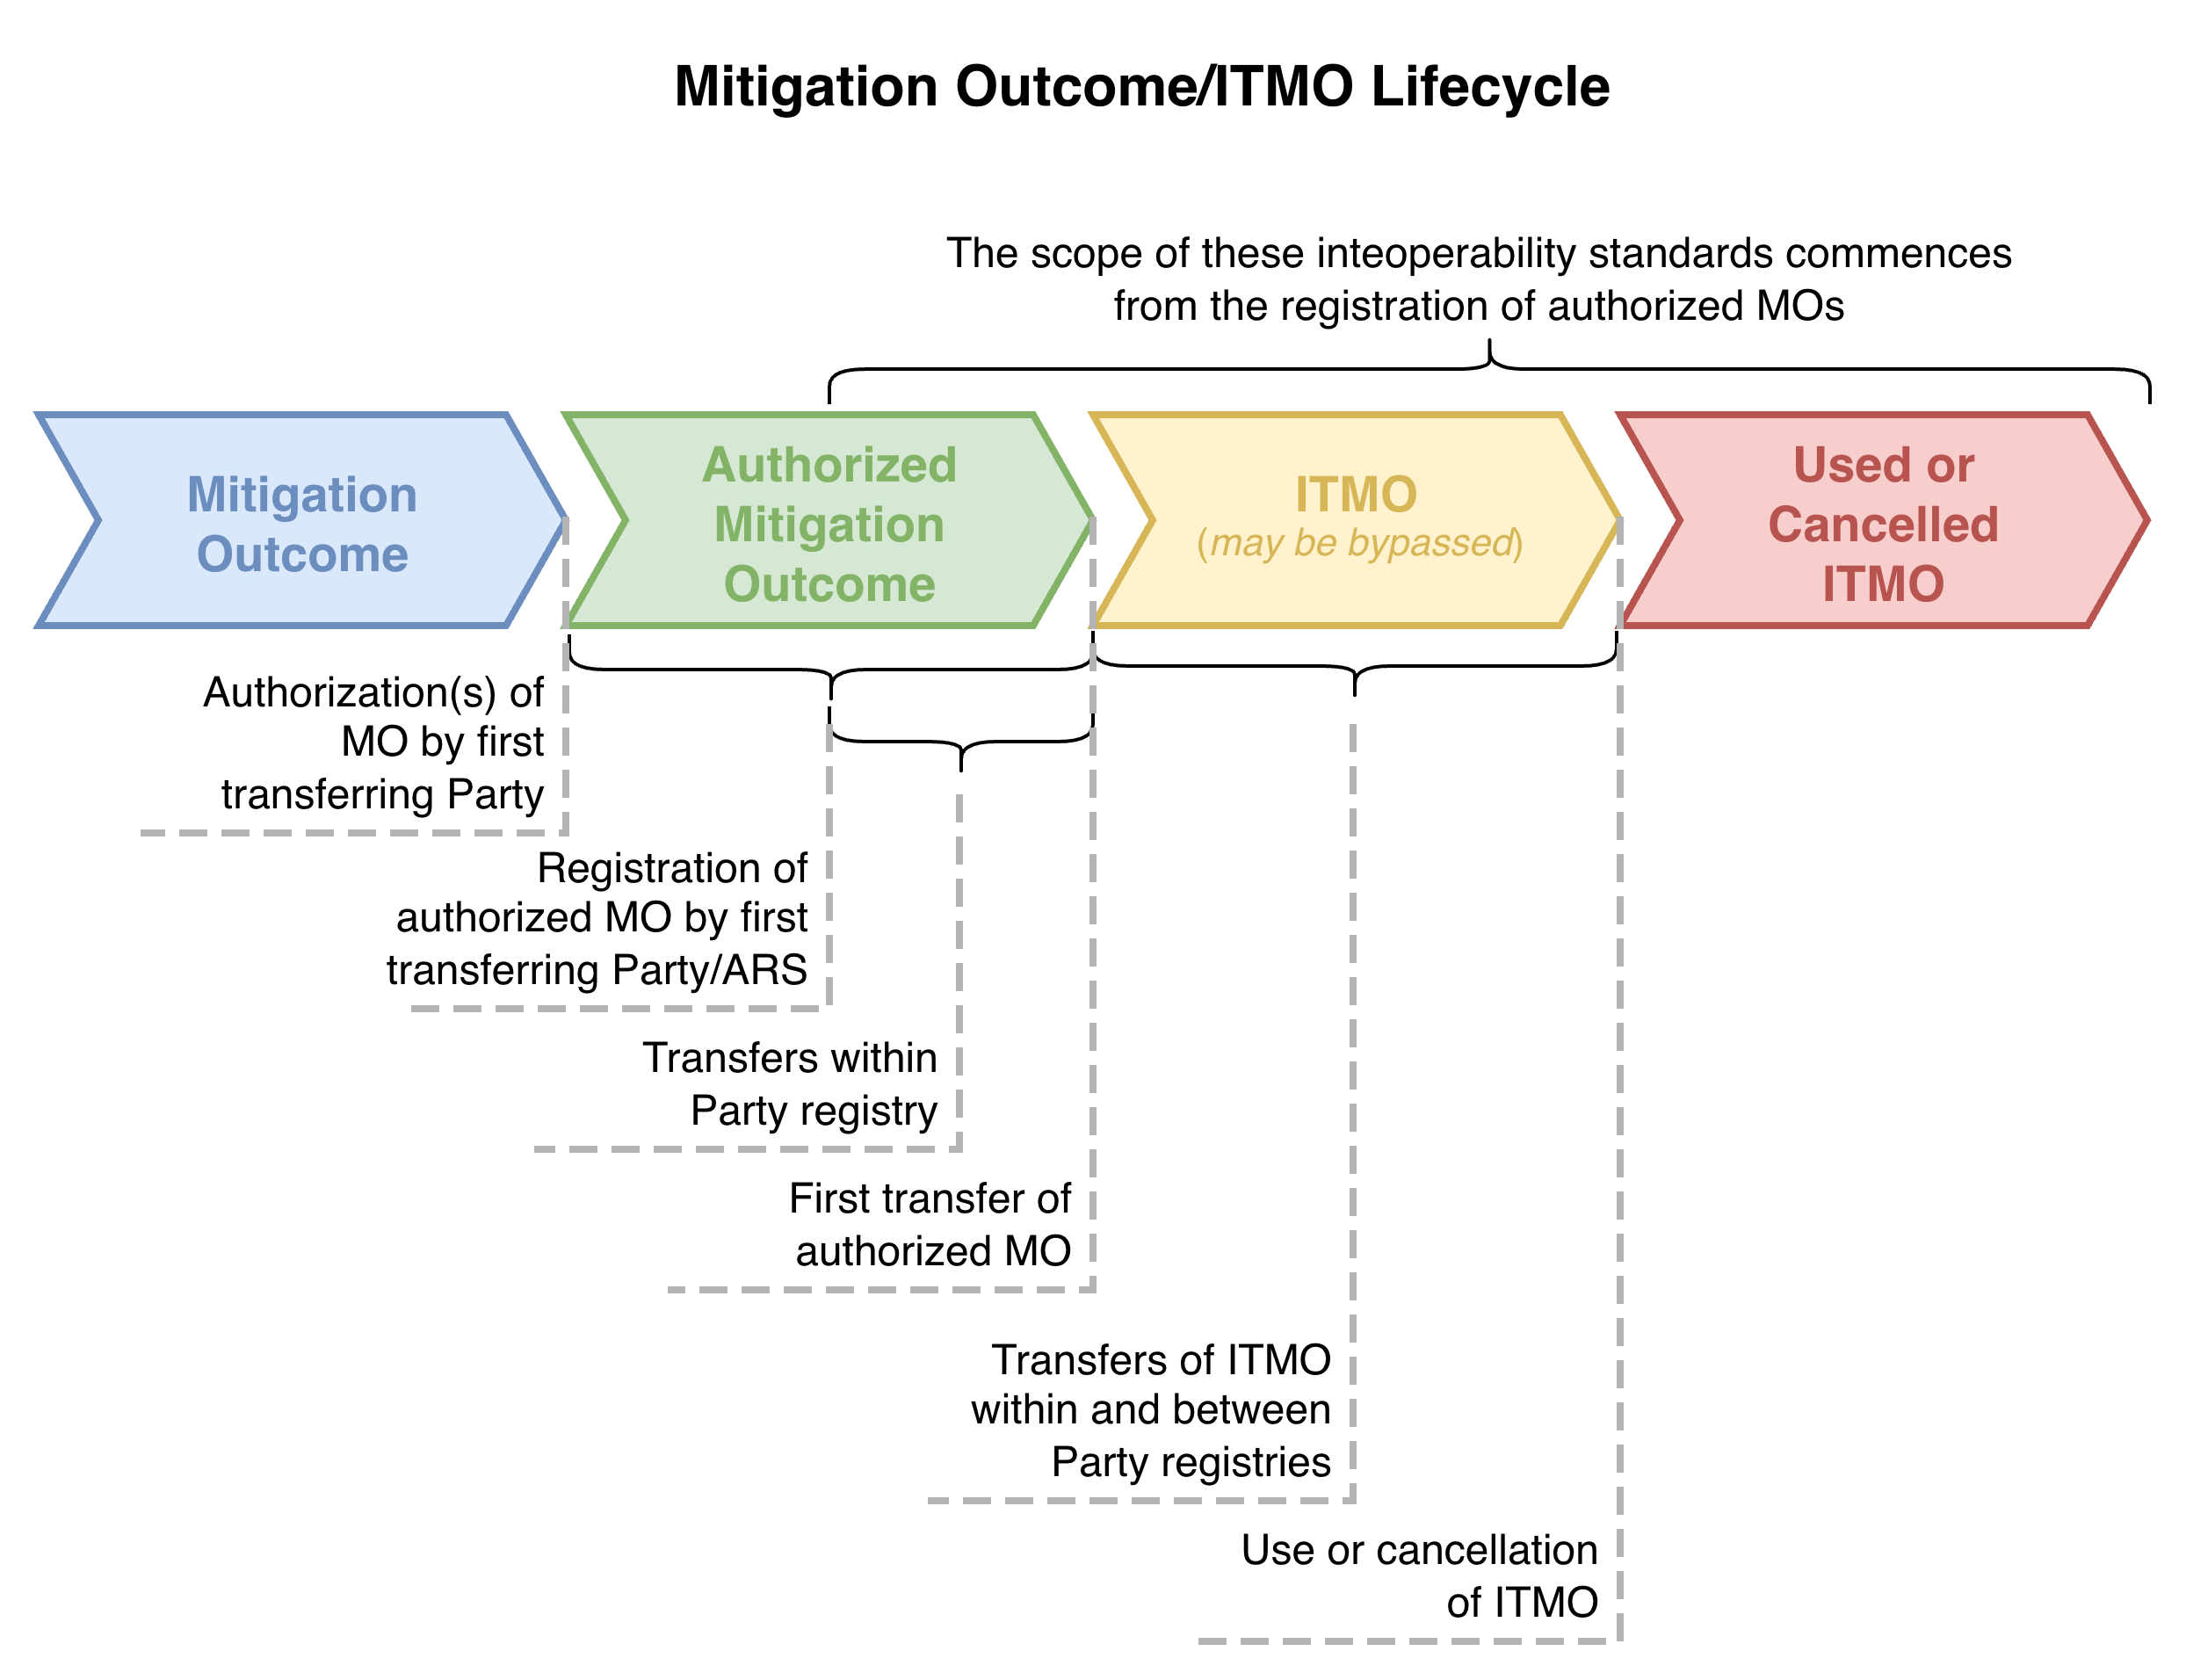
Figure 3 - Lifecycle of MOs and ITMOs

          - Mitigation Outcome Phase
            - A mitigation activity (decision 2/CMA.3, annex, para. 10) generating emission reductions and removals (decision 2/CMA.3, annex, para. 1(b), takes place in a host Party (decision 2/CMA.3, annex, para. 18(f)).
            - The host Party is also the “first transferring Party”
(Baku Table 3, footnote (e): first Transferring Party = “the participating Party in which the authorized mitigation outcome occurred as per common nomenclatures”)
            - The first transferring Party authorizes these mitigation outcomes (decision 4/CMA.6, annex, para. 11), and submits these authorizations to the secretariat, preferably using a voluntary standardized user-friendly template (decision 4/CMA.6, annex, para. 6).
            - The secretariat processes the information contained in these authorizations and stores them on the CARP (decision 4/CMA.6, annex, para. 35). Authorizations are available to all registries (including those that do not opt to apply the communication standards) through an API access to the CARP.
          - Authorized Mitigation Outcome Phase
            - Each participating Party has, or has access to, a registry (decision 2/CMA.3, annex, para. 29). A Party may build its own registry or use the international registry. This choice should be documented in the initial report (decision 2/CMA.3, annex, paragraph 18).
            - The authorized MOs are registered with interoperability hub.
            - The first transferring Party executes a first transfer of the authorized mitigation outcome by which the mitigation outcomes become ITMOs.
          - ITMO Phase
            - ITMOs may be transferred within and between Party registries (within the limits set by the decisions) until they are used or cancelled. In some instances, the first transfer is already the last valid transaction in relation to an ITMO.
            - ITMOs may also be used or cancelled by the holding registry, after which they become Used or Cancelled ITMOs. They may be:
- Used towards NDC (nationally determined contributions),
- Used towards IMP (international mitigation purposes),
- Cancelled for OP (other purposes),
- Cancelled for OMGE (overall mitigation of global emissions),
- Cancelled for administrative purposes, or
- Cancelled for a reason not described above.
            - For authorized MOs with a first transfer definition of Use or Cancellation, this phase may be bypassed, when the Use or Cancellation first transfer moves the authorized MO directly to a Used or Cancelled ITMO.
          - Used or Cancelled ITMO Phase
            - Used or Cancelled ITMOs may no longer be transferred.
  - Transactions
    - Transaction flows
          - A transaction may involve a single registry (e.g. use or cancellation), or two registries (e.g. transfer between two registries).
The flows are depicted in the sequence diagrams in the following subparagraphs.
The diagrams provide a high-level view of the communication between the registries and the interoperability hub, and how the registries use the API operations provided by the interoperability hub. Importantly, they show there is no requirement for registries to implement any APIs (they will only be clients to interoperability hub’s API) and the diagrams are not meant to dictate the internal processing of the registries.
            - Single Registry Transaction Flow – Valid Proposal
The sequence diagram for valid proposals involving a single registry is depicted in Figure 4 (the sequence diagram for an invalid proposal is depicted in Figure 6).
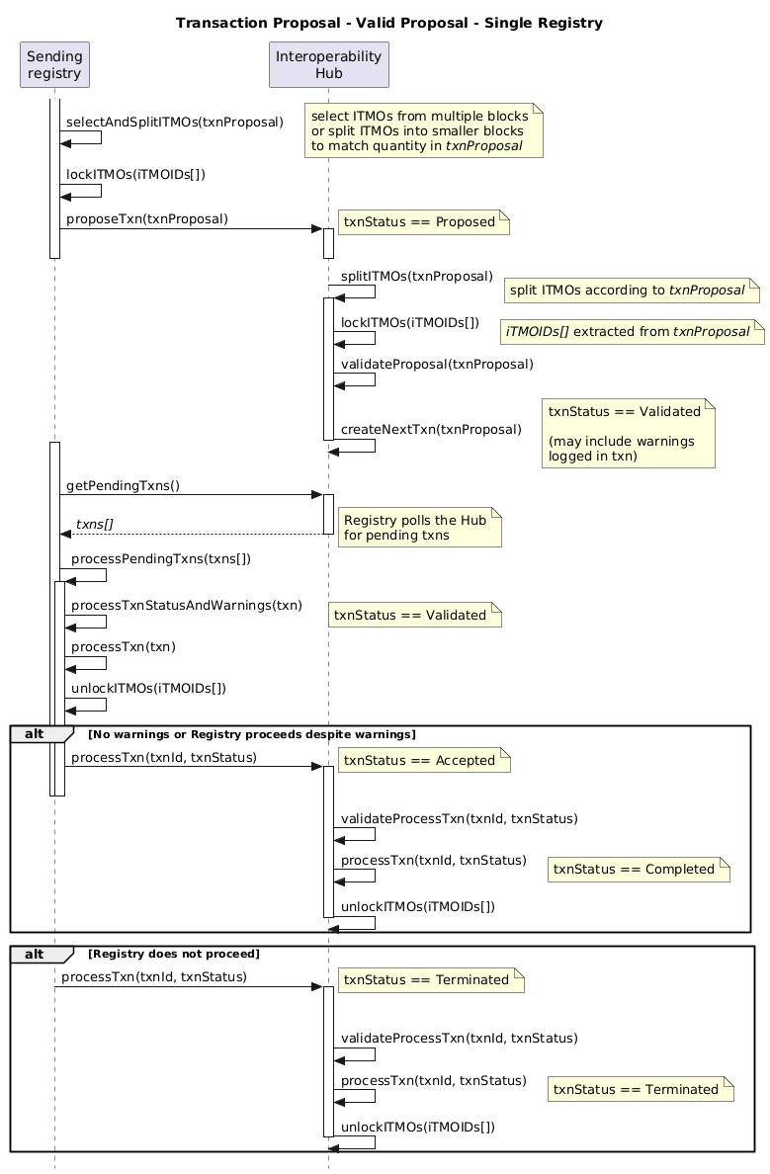
Figure 4 - Single Registry Valid Transaction Proposal Sequence Diagram

            - Two Registry Transaction Flow – Valid Proposal
The sequence diagram for valid proposals involving two registries is depicted in Figure 5 (the sequence diagram for an invalid proposal is depicted in Figure 6)
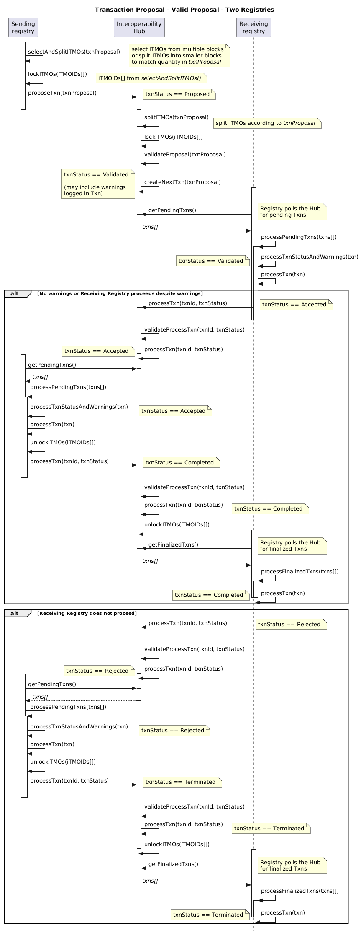
Figure 5 - Two Registry Valid Transaction Proposal Sequence Diagram

            - Single and Two Registry Transaction Flow – Invalid Proposal
The sequence diagram for invalid proposals is depicted in Figure 6. This is the same flow regardless of TransactionType, as the proposal will be invalidated by the interoperability hub.
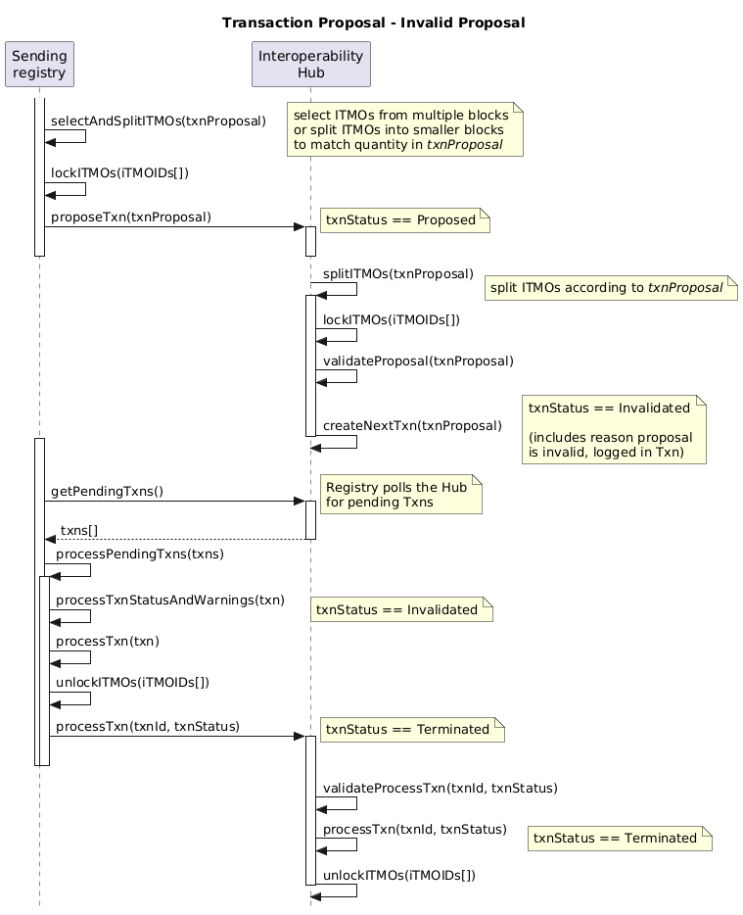
Figure 6 - Invalid Transaction Proposal Sequence Diagram

          - Transactions are initiated by registries using proposeTxn().
          - Prior to calling proposeTxn(), a sending registry MUST:
            - Select the ITMOs for the transaction (e.g. the appropriate quantity, vintage, cooperative approach);
            - Split or merge blocks of ITMOs as needed;
            - Lock the involved ITMOs so they are unavailable for other transactions;
            - Verify, to the best of its ability, that the Annex II validations will succeed.
          - On receipt of proposeTxn(), the interoperability hub MUST lock the ITMOs so they are unavailable for other transactions. If the ITMOs, or some subset of the ITMOs are already locked, the proposed transaction is deemed Invalid (txnStatus of the transaction is set to Invalidated).
          - The interoperability hub MUST validate a transaction proposed by a registry against the applicable annex II validations. If the transaction is validated, the interoperability hub MUST progress the transaction, possibly with warnings. If invalidated, the interoperability hub MUST return the reason(s) to the sending registry.
          - Registries MUST poll the interoperability hub to retrieve pending transactions in which they are involved, by using getPendingTxns(). It is recommended that this polling is periodic, with the following polling frequency:
            - Every 10 minutes (standard interval), but
            - At least once every 6 hours (to ensure updates are not missed), and
            - No more than once every minute (to prevent overwhelming the interoperability hub with polling requests). The interoperability hub MAY be configured to ignore more frequent requests.
          - Once a registry has retrieved and processed a pending transaction, it MUST use processTxn() to notify the interoperability hub of the result of its processing: set the transaction status to Accepted or Rejected; to Terminated or Completed.
          - The receiving registry MUST Accept or Reject a validated transaction proposal and inform the interoperability hub of its decision which MUST then notify this decision to the sending registry. If there were warnings during the validation of the transaction, the interoperability hub MUST include them in the notification to the ing registry.
          - When notified by the interoperability hub that a transaction it proposed has been Accepted, the sending registry MUST complete it. If notified that the transaction has been Invalidated or Rejected, the sending registry MUST Terminate it.
          - When the sending registry Completes a transaction, it MUST:
            - Create or modify the relevant ITMOs as necessary;
            - Unlock the involved ITMOs, so they are available for other transactions;
            - Notify the interoperability hub of that the transaction is Completed.
          - When the sending registry Terminates a transaction, it MUST:
            - Unlock the involved ITMOs, so they are available for other transactions;
            - Notify the interoperability hub of that transaction is Terminated.
          - When the interoperability hub is notified by the sending registry that it has Completed a transaction, it MUST:
            - Create or modify the relevant ITMOs as necessary;
            - Unlock the involved ITMOs, so they are available for other transactions.
          - When the interoperability hub is notified by the sending registry that it has Terminated a transaction, it MUST unlock the involved ITMOs, so they are available for other transactions.
          - Registries MUST periodically (recommended every 10 minutes, but at least once every 6 hours) poll the interoperability hub to retrieve finalized transactions in which they are involved, by using getFinalizedTxns().
          - Prior to retrieving the transaction with a Completed status, a receiving registry MUST NOT:
            - Perform any processing on the transaction’s ITMOs, and
            - Propose further transactions on the ITMOs.
          - If the receiving registry retrieves a transaction with a Terminated status, and it had Accepted the same transaction, the receiving registry MUST Terminate the transaction.
          - If a transaction is not finalized within 24-hours of the latest status update by the interoperability hub, the interoperability hub MUST initiate a timeout process (see section ‎6 below).
    - Registration of authorised MOs
          - An originating Party registry MAY register authorised MOs in a Holding account.
          - Before authorised MOs are registered:
            - The authorization of the MOs and their corresponding Cooperative Approaches must have been registered with the Secretariat and the CARP.
            - The originating Party registry MUST provide a unique identifier for the authorised MOs to be registered. This consists of:
                - The originating Party registry identifier,
                - The sequence number of the first MO in the block, and
                - The sequence number of the last MO in the block.
The identifier must be unique – that is, the block represented by the first sequence number and the last sequence number must not overlap with any authorised MO block previously registered by the same originating Party registry.
When stored in electronic systems, the unique identifier is stored with the three elements above. However, when presented as a textual string, the three elements are separated by a hyphen “-” character, and the sequence numbers use thousands comma separators. For example, “CHE00-1-3,142” represents the authorised MOs issued by the registry CHE00, with a first sequence number of 1, and a last sequence number of three thousand, one hundred and forty-two.
            - The originating Party registry MUST not propose multiple registrations of the same, or overlapping authorised MOs before the first registration transaction has completed or is terminated.
          - Registrations are initiated by an originating Party registry via proposeTxn(), with a TransactionType of Registration.
          - The authorised MOs registered MUST be represented as blocks – each block identifying a serial number range. An registration request MUST specify one or more blocks.
          - Upon receiving a registration request from a registry, the interoperability hub SHALL, inter alia, validate that:
            - All mandatory attributes of the authorised MOs are provided, as specified in Annex I;
            - The registry is not attempting the registration on behalf of another registry;
            - The fromAccount and toAccount fields of the transaction are the same, and their accountType = 100 Holding.
            - The authorised MOs being registered are unique – they do not overlap with another block of authorised MOs or ITMOs with the same originating Party registry;
            - The authorised MOs do not overlap with an existing, ongoing registration.
          - The registration process MUST follow the single-registry transaction flow outlined in Paragraph ‎III.B.1.26(a) and SHALL be subject to the validations performed by the interoperability hub specified in Annex II.
    - Transfer of ITMOs
          - A sending registry MAY propose a transaction to transfer ITMOs to a receiving registry, involving the movement of ITMOs represented as one or more blocks.
          - The proposed transaction MUST specify a sending account (to which the transferred ITMOs MUST be associated), and an existing receiving account, that MUST be different to the sending account.
          - The sending and receiving registry MAY be the same, in which case the transfer occurs between accounts of the same registry.
          - Upon receiving a transfer of ITMOs request from the sending registry, the interoperability hub SHALL, inter alia, validate that:
            - The sending registry and account hold the ITMOs the registry wishes to transfer;
            - The attributes of the transferred ITMOs match the attributes known to the interoperability hub for the sending registry;
            - The transferred ITMOs are not involved in another pending transaction (they are not locked by another transaction);
            - The transferred ITMOs are not inconsistent because of an ongoing reconciliation process.
          - The interoperability hub SHALL also validate that the attributes of the transferred ITMOs match the most recent values communicated through the announcement(s) of modification of ITMOs attributes process. If the interoperability hub detects any difference, it SHALL:
            - If the sending or the receiving registry has configured this validation is to be invalidated via configureValidation(): Invalidate the transfer.
            - If the sending and the receiving registry have configured this validation to be inactive via configureValidation(): append a warning to the affected ITMOs, informing the receiving registry of the difference(s) and send a textual message to the sending registry, informing it of the (potential) issue.
          - The interoperability hub SHALL forward any valid transfer request to the receiving registry, which MUST either accept or reject it.
          - The transfer of ITMOs process MUST follow the transaction flow outlined in Section ‎III.B.3and SHALL be subject to the validations performed by the interoperability hub specified in Annex II.
    - Splitting and merging blocks
          - The interoperability hub MUST automatically split blocks associated with serial number ranges, to match the blocks proposed by a registry, as part of its processing of transactions.
          - To reduce fragmentation, a registry and the interoperability hub MAY, from time to time, merge blocks that share the same attributes and are contiguous. Merging of blocks inside a registry or inside the interoperability hub MUST NOT be communicated, as it is an internal representation of blocks within these systems.
    - Transaction statuses
          - A transaction MUST have one status at any given time, which is REQUIRED to be one of the following:
            - Proposed: the transaction has been proposed by the sending registry and the ITMOs involved in the transaction are reserved exclusively for this transaction until it is finalized;
            - Validated: the proposed transaction has been validated by the interoperability hub. Validation tolerates minor discrepancies such as the authorization identifier of the proposed ITMOs being different to the most recent version in the CARP, however, warnings of these discrepancies are logged in the transaction, available for the receiving registry to consider;
            - Invalidated: the proposed transaction has been invalidated by the interoperability hub and MUST be terminated by the sending registry. An example is when the proposed ITMOs are currently locked by another concurrent transaction;
            - Accepted: the receiving registry has accepted the valid transaction proposal. The receiving registry processes the ITMOs involved in the transaction, as necessary;
            - Rejected: the receiving registry has rejected the valid transaction proposal;
            - Completed: the previously Accepted or Validated transaction is finalized. The sending registry either removes the ITMOs or updates them as required and the updated ITMOs are available for further transactions;
            - Terminated: the previously Invalidated, Rejected transaction is finalized. The sending registry does not update the ITMOs, but they are made available for further transactions. A transaction can also be Terminated if it is timed out by the interoperability hub (see section ‎III.B.6), or reverted (see section ‎III.B.7). A transition to the Terminated status MUST always be accompanied by a valid reason, which SHALL be one of the following:
              - Invalidated by the interoperability hub;
              - Rejected by the receiving registry;
              - Timed out by the interoperability hub;
              - Reverted.
          - Registries and the interoperability hub MUST ensure that the topological order of the statuses of transaction, as shown in Figure 7 below, is always respected. In addition, registries and the interoperability hub SHALL ensure that timestamps for each transaction status increase in order.
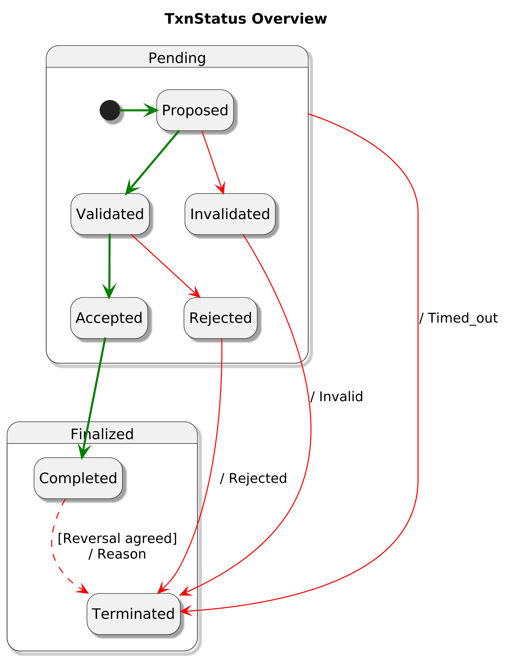
Figure 7 - Transaction status state diagram

          - The state diagrams in Figure 8 and Figure 9 show the relationships between the transaction statuses of the sending registry, receiving registry and the interoperability hub. Transitions related to transactions timeouts and reversal are omitted for simplicity.
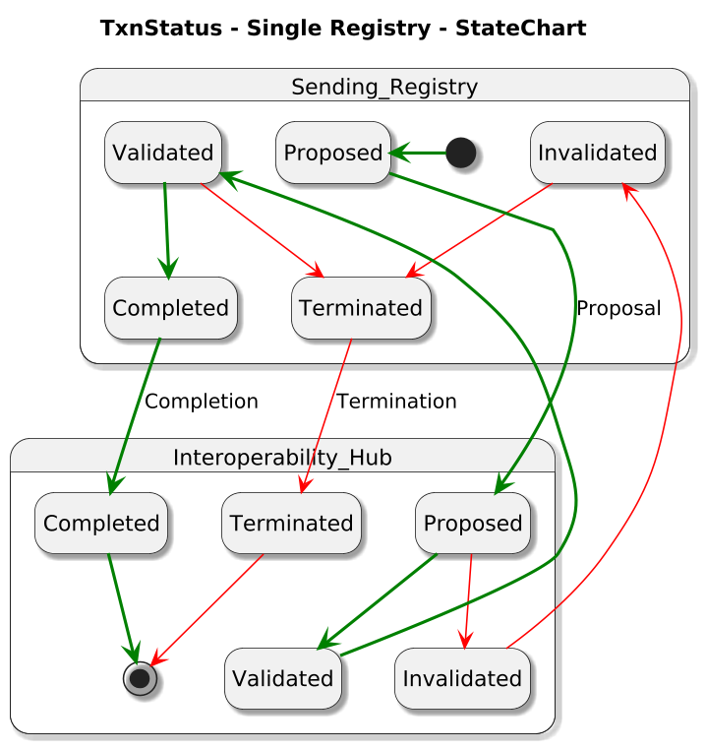
Figure 8 - Transaction state diagram - single registry transaction

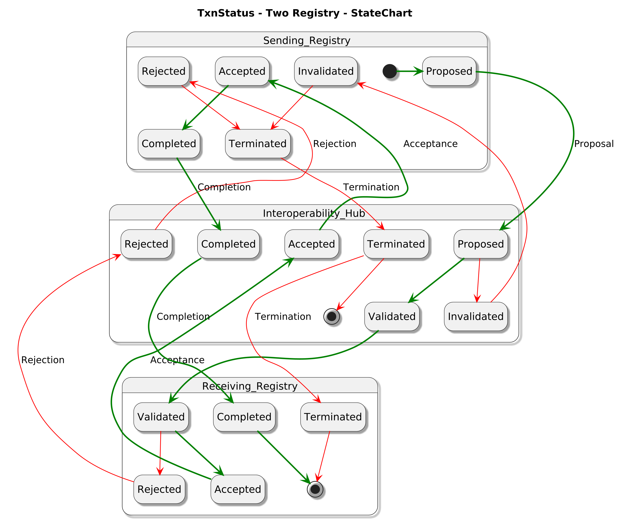
Figure 9 - Transaction state diagram - two registry transaction
    - Transaction timeout
          - If a transaction has not been completed within 24 hours after it was proposed, the interoperability hub MUST:
            - Terminate the transaction with a reason of Timed out;
            - Unlock the transaction’s ITMOs to make them available for further transactions.
          - A registry’s next successful getFinalizedTxns() call will retrieve transactions that have timed out, with a status of Terminated, the registry SHALL (see Figure 10 for sequence diagram):
            - Terminate the transaction, indicating the reason as timed out and unlocking all ITMOs involved in the transaction so they become available for further transactions;
            - Inform its registry administrator that the interoperability hub administrator MUST be contacted in all other cases (e.g. it already has been completed, which will lead to an inconsistency).
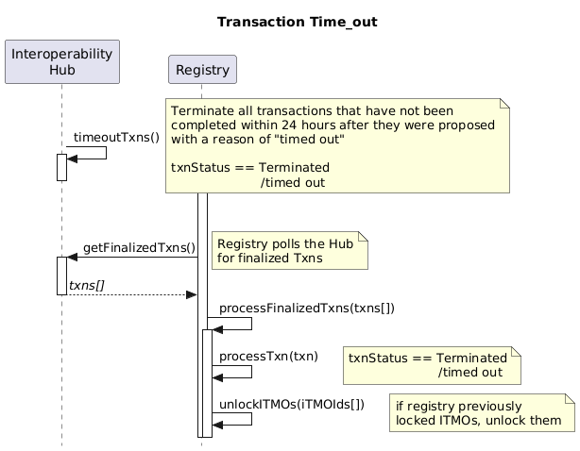
Figure 10 - Time-out Sequence
    - Reverting and correcting a transaction
          - In some situations, a registry administrator or the interoperability hub administrator MAY need to revert a previously completed transaction. These situations include accidental transaction proposals or resolving inconsistencies found during the reconciliation process. In this event:
            - A manual review of the case MUST be conducted, coordinated by the interoperability hub administrator;
            - If reverting the transaction is deemed feasible, the interoperability hub administrator MUST assign a unique identifier to the request: revertingId;
            - Using the revertingId, the registry administrator and the interoperability hub administrator manually revert the transaction, setting it to Terminated status, with a reason of “Manually reverted by <revertingId> on <date/time>”, and include in the reason any additional relevant details that justified the reversion.
            - The registry MUST return any ITMOs involved to their previous state and initiate a reconciliation.
          - An operational procedure detailing the process of reverting and correcting transactions MUST be established. This procedure MUST detail the specific conditions under which reverting or correcting a completed transaction MAY occur.
    - Requesting transaction details
          - A registry MAY request the details of a single transaction from the interoperability hub using getTxn(txnId), subject to the visibility rules in para. ‎79 below, and the interoperability hub is REQUIRED to respond within 60 seconds with the transaction details, including its status. If a registry is only interested in the status of a transaction, it MAY use getTxnStatus(txnId).
          - A registry MAY request the details of multiple transactions that satisfy a filter criteria from the interoperability hub using getTxns(mode, filter), this is described in more detail in para. ‎84 below.
    - Transaction validation configuration
          - There are two types of transaction validations:
            - Mandatory validations: these validations align with decisions and mandates, and cannot be turned off. If a transaction fails these validations, its TxnStatus MUST be set to Invalidated by the interoperability hub. These validations are listed in Table 2 of annex II;
            - Configurable validations: these are validations that SHOULD be used by all registries that help implement robust accounting within and between registries. While not intended to be a comprehensive set of business validations required by every registry, these validations reflect common practices and are included in the interoperability hub for ease of implementation. These validations, which can be configured, are listed in Table 3 of annex II. Each registry SHOULD also implement any additional business validations relevant to its Party and/or cooperative approach.
          - If a registry proposes a transaction that fails a configurable business validation, the interoperability hub MUST:
            - Set the transaction TxnStatus to Invalidated, if the validation is enabled; or
            - Keep the TxnStatus of the transaction unchanged and attach a warning about the failed validation to the transaction, if the validation is disabled.
          - configureValidation(validationId, registryRole, isOn) is used to configure a (configurable) validation:
            - validationId specifies the validation to be configured (as listed in Table 3 of annex II),
            - registryRole specifies when the configuration value is active: as the sending registry, as the receiving registry, or as either sending or receiving registry; and
            - isOn specifies whether the configuration is to switch the validation on or off. Note that even if the validation is switched off, if a transaction fails the validation, the interoperability hub MUST attach a warning to the transaction.
  - Announcement of modification of ITMOs attributes
          - When any modification to attributes (e.g., authorization id, authorization version, vintage and/or mitigation outcomes) of ITMOs occur, the first transferring participating Party of the ITMOs SHOULD promptly announce the changes to the interoperability hub.
          - Upon receiving such announcement, the interoperability hub is REQUIRED to:
            - Identify all affected ITMOs;
            - Verify the changed values;
            - If the change values verify, add a notification for all registries holding the affected ITMOs. These notifications SHALL indicate the affected ITMOs, the account identifiers holding the affected ITMOs, and the updated values of the attributes.
          - Upon retrieving the notification of modification of ITMO attributes, a registry SHOULD take appropriate transactions, which SHOULD include updating the relevant attributes of the affected ITMOs.
          - Once a registry acts on a notification by updating the ITMO, it SHALL acknowledge the notification by calling acknowledgeNotification(). Then, it will no longer receive notifications for that ITMO update from getPendingNotifications(), for example Holding Registry 1 in Figure 11.
          - On receiving the acknowledgeNotification() request from the registry, the interoperability hub SHALL update the relevant attributes of the ITMOs to maintain consistency with the holding registry.
          - If a registry does not act on a notification, for example, Holding Registry 2 in Figure 11, it will continue to receive notifications for that ITMO update from getPendingNotifications(). Further, when it attempts to transfer the ITMOs, the transaction proposal will include a warning that attributes of the ITMO are inconsistent with that of the first transferring participating Party.
          - Once a registry no longer holds any affected ITMOs, notification for the ITMOs MUST no longer be created for it by the interoperability hub.
          - If a registry acquires ITMOs subject to a pending notification of modification, it SHALL receive broadcast announcements from the interoperability hub, noting that the ITMOs received will also contain a warning appended to them by the interoperability hub.
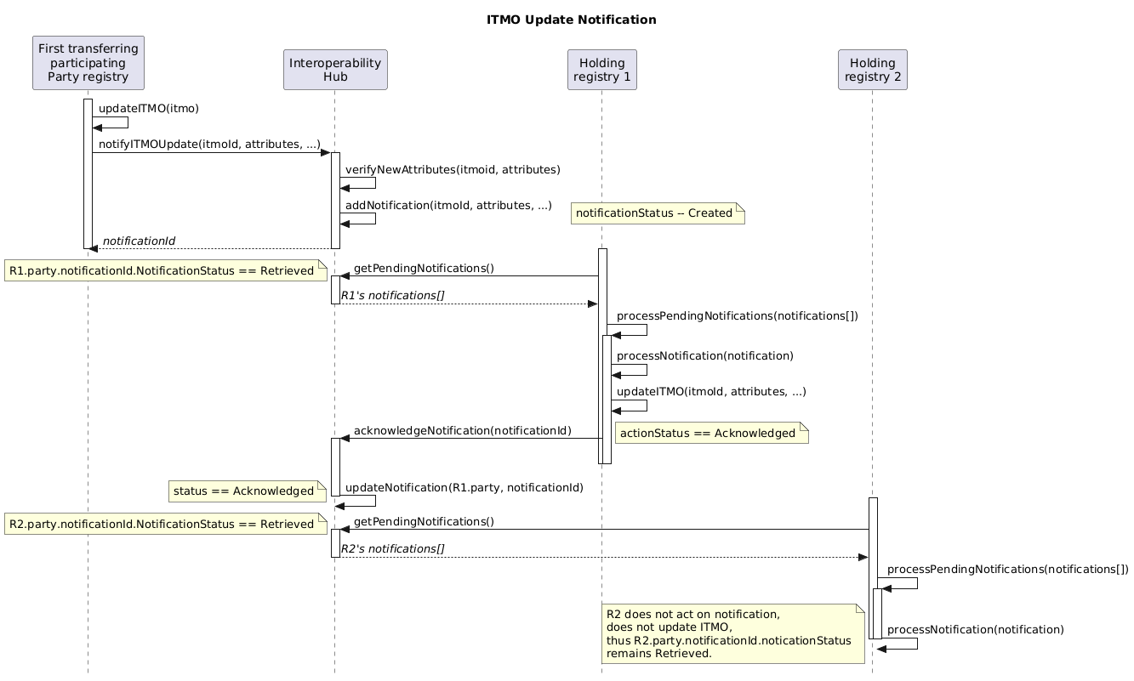
Figure 11 - Notification of update of ITMO attributes
  - Pulling and viewing holdings and transaction history of ITMOs
          - The interoperability hub MUST support the API operations listed in this section to allow for pulling and viewing of data and information on holdings and the transaction history of ITMOs.
          - When a calling registry retrieves information on transactions of ITMOs, the interoperability hub MUST enforce the following visibility rules:
              - The calling registry MUST have proposed the transaction(s), or
              - The calling registry MUST have received the transaction(s), if it was the receiving registry in a two-registry transaction flow and if the transaction(s) have reached the Validated status (i.e., Invalidated transactions are not visible to the receiving registry).
          - When a calling registry retrieves information on accounts, ITMOs and transactions of ITMOs, it MAY specify a mode as follows:
            - Registry mode: returns the accounts created by-, the ITMOs held by-, and the transactions visible to-, the calling registry;
            - Party mode (default): the accounts created by-, the ITMOs held by-, and the transactions visible to-, any of the registries belonging to the Party of the calling registry.
          - The interoperability hub MUST ensure that the retrieved information on accounts, ITMOs and transactions of ITMOs is browsable and filterable.
          - getAccounts() returns selected accounts, subject to the visibility rules above. The selected accounts MUST be returned in descending order based on their creation date (i.e., recently created accounts are returned first). Filter:
            - Registry or Party mode: see above. If not specified, Party mode is assumed.
          - getITMOs() returns selected ITMOs, subject to the visibility rules above. The selected ITMOs MUST be returned in ascending order based on their identifier. Filters:
            - Registry or Party mode: see above. If not specified, Party mode is assumed;
            - Account identifier: an account identifier holding the ITMOs. If not specified, all ITMOs are selected.
          - getTxns() returns selected transactions, subject to the visibility rules above. The selected transactions MUST be returned in descending order based on their Proposed status date and time (i.e., recently proposed transactions are returned first). Filters:
            - Registry or Party mode: see above. If not specified, Party mode is assumed;
            - Transaction status: the transaction status (e.g. Validated) of the transactions to select. If not specified, all transaction statuses are selected;
            - Minimum date and time: minimum date and time based on the Proposed status timestamp recorded by the interoperability hub. If not specified no minimum date and time applies;
            - Maximum date and time: maximum date and time based on the Proposed status timestamp recorded by the interoperability hub. If not specified no maximum date and time applies;
            - fromRegistry: only transactions from fromRegistry are returned. If not specified transactions from all registries are selected;
            - fromAccount: only transactions from fromAccount are returned. If not specified transactions from all accounts are selected;
            - toRegistry: only transactions to toRegistry are returned. If not specified transactions to all registries are selected;
            - toAccount: only transactions to toAccount are returned. If not specified transactions to all accounts are selected.
  - Account management
          - A registry MUST declare to the interoperability hub the accounts it plans to use for transactions, either as sending or receiving accounts. Each account MUST have a type listed in tTable 5 of Annex III.
          - A registry SHALL NOT make any other information about the account(s) to the interoperability hub besides the account identifier(s) and account type(s), and the interoperability hub SHALL NOT store any other information about the account(s) besides the account identifier(s), account type(s) and its holdings. In particular, no information about the person(s) or entities owning the account SHALL be communicated or stored.
          - To manage its accounts, additionally to getAccounts() (see para. ‎82), a registry MAY call:
            - insertAccount() to add a new account. If an account with the same account identifier already exists, the operation MUST fail;
            - removeAccount() to remove an account. If the account holds ITMOs, or if the account is part of an ongoing transaction, the operation MUST fail.

  - Reconciliation management
    - Reconciliation between registries and the interoperability hub
          - Reconciliations between registries and the interoperability hub SHALL be based on the history of finalized transactions and on ITMO holdings as at 00:00 UTC of the current day. Pending transactions and/or transactions proposed and finalized after 00:00 UTC, and their resulting changes on ITMO holdings, MUST be ignored.
          - A registry SHOULD provide to the interoperability hub, daily, the list of its finalized transactions and ITMO holdings as at 00:00 UTC and request the interoperability hub to perform a comparison with its own transactions and holdings. Upon receiving this request, the interoperability hub MUST:
            - Compare the list of transactions of ITMOs provided by the registry with its own, producing a list of differences (i.e., inconsistencies);
            - Compare the ITMO holdings provided by the registry with its own, producing a list of differences (i.e., inconsistencies), while respecting the ITMO block boundaries of the registry;
            - Return the list of differences of transactions and holdings to the registry, within 60 seconds of its request.
          - These standards provide reconcile(txns[], itmos[]) for this purpose:
            - The registry’s list of finalized transactions is provided in the txns[] list;
            - The registry’s holdings are provided in the itmos[] list;
            - reconcile() returns a list of differences between the registry and the interoperability hub transactions, and a list of differences between the registry and the interoperability hub holdings.
          - The registry administrator of the registry and/or the interoperability hub administrator SHOULD promptly correct any inconsistencies in their respective systems, based on the comparison of the transactional history and inconsistent ITMOs, and any other pertinent elements.
    - Reconciliation within registries and within the interoperability hub
          - When a transaction is finalized, the interoperability hub MUST verify that its transactional history leads to the balance of ITMOS in each account (i.e., it performs an internal reconciliation of its records). Registries are RECOMMENDED to perform a similar verification. Registries MUST NOT communicate the results of these internal verifications to the interoperability hub.
    - Creating inconsistencies
          - In test environments, a registry MAY call createInconsistency() which will introduce the following inconsistencies in the interoperability hub:
            - Create an additional Completed transaction and adjust the registry holdings accordingly;
            - Delete an existing transaction without modifying the associated holdings;
            - Add a block of ITMOs without generating the corresponding transaction;
            - Modify the vintage of an ITMO without recording the corresponding transaction.
    - Operational procedure
          - An operational procedure detailing the process of reconciliation MUST be established.
  - Registry management
    - Interoperability hub status
          - getServerStatus() returns the operational status of the interoperability hub (i.e., operational, non-operational or transaction proposals are disallowed) along with its date and time.
    - Registry creation
          - Once a registry administrator has configured its registry with a valid API key, createRegistry() MUST be used to create an empty registry space in the interoperability hub, providing at least two valid contacts. In the production environment, the created registry MUST belong to the Party linked to the API key used by the calling registry. In test environments, non-Party registries MAY be created. Upon creation, interoperability hub MUST set the registry operational status to non-operational.
    - Registry contacts
          - A registry SHOULD keep its contact information up-to-date by using insertContact() and/or removeContact(), in addition to specifying at least two contacts at the time of registry creation. The interoperability hub MUST use this information to keep the contact lists on the online platform accurate.
    - Registry operational status
          - A registry SHOULD notify the interoperability hub of its operational status using setRegistryOpStatus(status). The operational status of a registry MUST be one of the following:
            - Operational: all operations MUST be allowed;
            - Non-operational: no operations MUST be allowed;
            - Transactions disallowed: all operations MUST be allowed except for transaction processing.
          - The interoperability hub MUST invalidate a transaction involving a non-operational registry.
          - The interoperability hub MUST allow manual updates to the operational status of a registry.
          - Before it proposes a transfer of ITMOs, a registry SHOULD query the interoperability hub about the operational status of the receiving registry and SHOULD ensure that it is operational. getRegistryOpStatus(regId) returns the operational status of the registry identified by regId, according to the interoperability hub.
          - An operational procedure detailing the process of setting the operational status of a registry MUST be established.
    - Test registry reset and removal
          - resetTestRegistry(regId) MAY be used in test environments to reset a registry data. Calling this operation results in the removal of all holdings, transactions, accounts of the registry with identifier regId, including all ITMOs issued by the registry and held in other test registries, all transactions to/from the registry and all accounts it created. This operation MUST NOT alter the operational status of the registry, or its contacts. It SHALL NOT be available in the production environment.
          - deleteTestRegistry(regId) SHOULD be used to delete a test registry from the interoperability hub. Calling this operation results in the removal of all holdings, transactions, accounts of the registry with identifier regId, including all ITMOs issued by the registry and held in other test registries, all transactions to/from the registry and all accounts it created. It SHALL NOT be available in the production environment.
    - Registry onboarding
          - A registry SHALL be considered ready to undertake transactions in the production environment, when:
Manual initial setup:
            - The Party of the registry has nominated at least two registry administrators;
            - The registry administrator has access to the online platform;
            - The registry IP address is known and whitelisted;
            - The registry administrator has received the required API key(s) and configured them in its registry.
API operations initial setup:
            - The communication between the registry and the interoperability hub is established and time of the registry and the interoperability hub is confirmed to be synchronized, using getServerStatus(). Confirmation that the time of the registry is synchronized is based on the interoperability hub administrator review of the request timestamp, and is provided as a textual message (see below);
            - Textual message is confirmed working, using getSelectedMsgs();
            - The registry is created, using createRegistry();
            - The registry is in status operational, using setRegistryOperationalStatus();
            - Any additional registry contacts are available, using insertContact();
            - Transaction validations are configured, using configureValidation();
            - The required accounts have been created, using insertAccount().
  - Data export
    - Agreed Electronic Format
          - A registry MAY request a pre-filled AEF file export pursuant to decision 2/CMA.3, Annex, chapter IV.B (Annual information). The exported file(s) are formatted in accordance with decision -/CMA.6, annex II.
          - The AEF template used during the export MUST be the one available at
https://unfccc.int/documents/644483.
          - The cooperative approach and authorisation data required by the AEF reports are not fully stored in the interoperability hub. Instead, exportAEFActions() and exportAEFHoldings() retrieve the necessary information from the CARP.
          - exportAEFActions() exports AEF actions as an Excel file. The export includes only a filled-in “Table 3 Actions” AEF sheet. Only transactions with a Completed status and timestamp within this range MUST be included. The same visibility rules as in getTxns() (see para. ‎D.84 above) MUST apply. Table 2 below maps transactions to AEF actions for action exports. Filters:
            - Registry or Party mode: see para. ‎D.80 above. If not specified, Party mode is assumed;
            - Minimum date and time: minimum date and time of the transactions/actions to export, based on the Completed status timestamp recorded by the interoperability hub. If not specified, January 1st of the year preceding the current year applies (i.e., an AEF export of the previous calendar year is expected);
            - Maximum date and time: maximum date and time of the transactions/actions to export, based on the Completed status timestamp recorded by the interoperability hub. If not specified, December 31st of the year preceding the current year applies (i.e., an AEF export of the previous calendar year is expected).
            - Limit: the maximum number of actions in this export.
          - exportAEFHoldings() exports ITMO holdings as an Excel file. The export includes only a filled-in “Table 4 Holdings” AEF sheet. The calling registry MUST provide a cut-off date for the export, which represents the ITMO holdings on that date. The same visibility rules as in getITMOs() (see para. ‎D.84 above) MUST apply. Filters:
            - Registry or Party mode: see para. ‎D.80 above. If not specified, Party mode is assumed;
            - First transferred only: Only export ITMOs that have isFirstTransferred = TRUE; otherwise export all ITMOs.
            - Cut-off date: date and time of the ITMOs holdings to export (i.e., the ITMO holdings is the result of all Completed transactions until the cut-off date). If not specified, December 31st of the year preceding the current year applies (i.e., an AEF export of the previous calendar year is expected).
Table 1 - Mapping transactions to AEF Actions
Transaction | AEF Action
Registration  Same sending/receiving registries  Same sending/receiving accounts | Not reported in AEF
Transfer  Different sending/receiving registries | Acquisition  Reported by receiving Party
Transfer  Different sending/acquiring registries | Transfer  Reported by sending Party
Use  Internal transfer to a  “Use for NDC” or  “Use for OP” account | Use  The destination account type is used to infer the AEF Action subtype.
Cancellation  Internal transfer to any “Cancellation” account | Cancellation  The destination account type is used to infer the AEF Action subtype.
Not a transaction type, but indicated by the isFirstTransfer flag in the transaction, set by the registry that proposes the transaction. | First transfer
    - Preservation file
          - The interoperability hub SHALL export, on a monthly basis, all transactions, ITMO holdings, and any other pertinent information it holds in a long-term preservation file. One long-term preservation file SHALL be created per registry, in CSV format following RFC 4180, compressed to TAR and GZIP following POSIX.1-2001 and RFC 1952. A registry MAY request, from time to time, to receive its long-term preservation file. The long-term preservation file SHALL be sorted to allow for optimal compression.
          - An operational procedure detailing the process and practices related to data retention, including the precise content and format of the long-term preservation file, record-keeping arrangement and disaster recovery SHALL be established.
  - Textual message
          - A registry SHOULD be able to send textual messages to the interoperability hub using sendMsg().
          - The interoperability hub MUST be able to send textual messages to one or more registry system administrators. Registries will retrieve these messages using getSelectedMsgs().
          - A textual message MAY be accompanied by one or more attachment(s) in JPG, PNG or PDF format.
- Technical requirements
  - Time synchronization
          - Registries and the interoperability hub are REQUIRED to synchronize their time with UTC.
          - The timezone of timestamps described in these standards are UTC.
          - Registries SHALL provide the date and time at which each request originated in the HTTP header “Date”, in accordance with section 5.6.7 of RFC 9110. The interoperability hub SHALL reject any request missing this header.
          - When a request is received, the interoperability hub MUST compare the time contained in the HTTP “Date” header with its own time. If the time difference is greater than 60 seconds, the interoperability hub MUST reject the request.
  - Timeouts and maximum payload size
          - Registries and the interoperability hub are REQUIRED to apply the following timeouts:
            - (Registries) Connection timeout: 30 seconds;
            - (Registries) Read timeout: 60 seconds;
            - (Interoperability hub) Request read and processing timeout: 60 seconds.
          - The following HTTP maximum payload sizes SHALL apply:
            - Request headers MUST NOT exceed 8190 bytes;
            - Request body MUST NOT exceed 10 MB, unless otherwise specified;
            - Response body MUST NOT exceed 10 MB, unless otherwise specified.
  - Security
          - Registry system administrators MUST be nominated by their respective national focal points. Once nominated, a registry system administrator MAY nominate additional contacts to support the operation of its registry. The interoperability hub administrator SHALL ensure that it only allows communications to and from registry system administrators and nominated contacts.
          - One-way TLS 1.3 MUST be implemented to guarantee the security of communications. The cipher suite TLS_AES_256_GCM_SHA384 (value: {0x13,0x02}, see RFC 8446, section 9.1 and Appendix B.4), MUST be used. The interoperability hub is REQUIRED to reject other versions of TLS and/or other cipher suites.
          - Each registry MUST have one static IP address, which MUST be whitelisted in the interoperability hub. Conversely, the interoperability hub MUST maintain one static IP address that is whitelisted in each registry.
          - When establishing a connection with the interoperability hub, a registry MUST validate public certificate of the interoperability hub by:
            - Verifying its chain up to a trusted root certificate authority;
            - Check its validity period;
            - Verify its hostname;
            - Check that its key usage and extended key usage are as expected;
            - Validate its signature;
            - Check it for revocation;
            - Verifying that it has been generated using the agreed upon encryption algorithm(s).
          - API keys SHALL be used for authorization, in the form of tokens provided by registries in the HTTP request header “X-API-Key”. HTTP Basic authentication SHALL NOT be used. The interoperability hub administrator is responsible for the management and distribution of API keys used in the registry system and SHALL operate an API key management tool as a sub-component of the interoperability hub.
          - API keys MUST follow the format: <Registry> - <Environment> - <Component > - <Nonce> - <Checksum>, where:
            - Registry adheres to the format of annex I, section 1(a);
            - Environment is “PROD” or “TEST”;
            - Component is “USER”;
            - Nonce is a cryptographically secure 256-bit random value, in hexadecimal, generated by the calling registry for each HTTP request;
            - Checksum is used to verify the authenticity and integrity of the API key, using HMAC-SHA256, hexadecimal, truncated to the first 6 characters. The interoperability hub administrator SHALL manage, as part of the API key management tool, the shared secret keys used to create the checksum.
          - An example of a valid API key, using “SharedSecretKey” for checksum calculation, is:
CHE01-PROD-USER-ba24600bd49af0bf345213a9b6ec44e3-efe808 .
          - When the interoperability hub receives a request, it MUST reject it if:
            - The registry IP address is not whitelisted;
            - The API key provided is not valid for use, including:
            - The IP address, API key, and identification of the registry in the request do not match.
          - If a registry provides a nonce has been used previously, or fails to provide a correct checksum three times, the interoperability hub SHALL automatically set that registry to non-operational status until the issue is investigated and resolved.
          - An operational procedure that is shared only with registry MUST be established, that will contain further details and procedures related to communication security.
  - Sandbox testing environment
          - The interoperability hub MUST provide a sandbox testing environment which registry administrators are RECOMMENDED to use for testing before deploying their registries to the production environment.
          - The sandbox testing environment SHALL allow registry administrators to:
            - Create and remove, using createRegistry() and deleteTestRegistry(), other non-Party registries for testing transfer of ITMOs between them;
            - Reset the content of both its test registry and of any non-Party registry it created, using resetTestRegistry();
            - Configure transaction validations, using configureValidation();
            - Create inconsistencies to test reconciliations, using createInconcistency().
          - The interoperability hub MAY automatically clear the sandbox testing environment of a registry if there has been no activity for that registry for two weeks.
          - The security of the sandbox testing environment SHALL be adapted, as needed, to facilitate testing.
          - The usage of the sandbox testing environment SHALL be further detailed in an operational procedure.
  - Consolidated system
          - A registry MAY be consolidated with other registries in a consolidated system if it meets the following conditions:
            - It MUST have a unique registry identifier;
            - It MUST have its own static IP address and API keys;
            - It MUST interoperate with other registries using these standards.
          - A registry administrator of a Party registry that is consolidated MAY delegate its authority to the administrator of the consolidated system it is part of.
  - Internationalization
          - Internationalization SHOULD be achieved as follows:
            - The use of numerical identifiers and codes SHOULD be preferred to strings, where possible;
            - When strings are used, they SHOULD use Unicode in accordance with JSON Schema Specification Draft 2020-12.
          - Registry administrators are RECOMMENDED to provide localized versions of the numerical identifiers and codes within their registry.
  - Data retention and preservation
          - The interoperability hub is REQUIRED to retain all messages it receives from registries throughout its operational lifetime and for five years thereafter.
          - A registry SHOULD retain all messages it sends to the interoperability hub throughout its operational lifetime and for at least two years thereafter.
  - API standard and lifecycle management
          - These standards SHALL use the OpenAPI Specification 3.0.3.
          - The endpoints APIs MUST be subject to lifecycle management, and SHALL adhere to the following principles:
            - The OpenAPI “info.version” field is REQUIRED to be set to a string containing the major and minor version of the API (e.g. 1.0);
            - The “basePath” field is REQUIRED to include the major version number and MUST be formatted as the letter “v” followed by major version number (e.g. /v1).
          - When a new API version has backwards-compatible changes, such as adding new fields or methods without modifying existing ones, the minor version MUST be incremented in the “info.version” field (e.g. 1.0, 1.1, 1.2 …).
          - When a new API version has changes to an existing method that breaks client code:
            - The major version number in the “info.version” field MUST be incremented (e.g. 2.0, 3.0, …);
            - The major version number in the “basePath” field. MUST be incremented (e.g., /v2, /v3, etc.).
          - These standards SHOULD aim to introduce changes at a low rate (preferably, none) and in a backward-compatible manner, as any disruptive change would severely impact registry systems. Consequently, the initial version of the APIs SHOULD be as comprehensive as possible.
          - The interoperability hub is REQUIRED to support multiple major versions concurrently, subject to coordinated deployments across registries. This process MUST be detailed in an operational procedure related to change management.

Annex I – Attributes of ITMOs
    - ITMO unique identifier
          - An ITMO identifier SHALL be composed of an Originating Party registry Id and a serial number range (firstId, lastId).
      - Originating Party registry Id
          - An ITMO is REQUIRED to include the identifier the registry that registered it (as an authorised MO, in paragraph 23), referred to as the Originating Party registry Id. This identifier is composed of two elements:
            - The Party Id, based on the ISO 3166-1 alpha-3 country code, concatenated with
            - A two-digit sequence number that is unique for each Party Id.
When stored electronically, the registry identifier is stored these two elements, however, when presented as a textual string, the two elements are concatenated. For example, if the Party ABC had a single registry, its registry identifier would be “ABC00”.
          - The Originating Party registry Id is included in an ITMO’s unique identifier because the originating registry is responsible for issuing the ITMO and generating its unique identifier. This allows the originating registry to manage serial number ranges and ensure that all ITMOs it issues are distinct and do not overlap (i.e., are unique).
          - The ISO 3166-1 alpha-3 user-assigned code element “AAA” SHALL be reserved for the Article 6.4 mechanism registry.
          - For testing purpose, an ITMO MAY be issued by a non-Party registry. In such case, an ISO 3166 alpha-3 user-assigned code element MUST be used (e.g., AAB to AAZ, QMA to QZZ, XAA to XZZ, ZZA to ZZZ are available).
      - Serial number range
          - An ITMO MUST have a firstId and a lastId, that represent the start and end of a block, inclusive (i.e., 1<= startId <= lastId).
          - For each Originating Party registry Id, serial number ranges MUST NOT overlap.
    - Cooperative approach Id
          - An ITMO is REQUIRED to have one cooperative approach. The cooperativeApproachId SHALL be a reference to the cooperative approach as published by the UNFCCC secretariat on the CARP.
    - First transferring Party
          - An ITMO is REQUIRED to have a first transferring Party which MUST be the Party in which the authorized mitigation outcomes of the ITMO occurred. The firstTransferringParty of an ITMO SHALL be identified by its three-letter code as defined in ISO 3166-1 alpha-3 (e.g., “CHE” for Switzerland). For participating Party registries, the first transferring Party SHALL be the same as the Party Id of the Originating Party registry Id.
    - Vintage
          - An ITMO is REQUIRED to have a vintage year within the range 2021 to 2100, inclusive.
    - Unit type
          - An ITMO is REQUIRED to have a unit type equal to 1. This attribute is reserved for future use.
    - Authorization
      - Authorization Id
          - An ITMO is REQUIRED to be authorized. The authorizationId SHALL be a reference to the ITMO Authorization as published by the UNFCCC secretariat on the CARP.
      - Authorization version
          - An authorization MAY be updated after initial registration with the CARP. An ITMO is REQUIRED to be traceable to the version of the authorization that was registered. This will be through the ITMO’s authorizationVersion.
    - Is First Transferred
          - Once an ITMO undergoes the first transfer, this flag is set, and cannot be unset, except if the proposed first transfer transaction of the ITMO is invalidated by the interoperability hub, or is rejected by the proposed acquiring Party. ITMOs that have been first transferred, cannot be subject to another first transfer.
    - Party ITMO registry Id
          - An ITMO MUST be trackable, thus, the current registry holding the ITMO is recorded in the ITMO. This is identified by the partyITMORegistryId. Its format is the same as the one of point 3 (Originating Party registry Id) above. Note that there are special cases where the registry holding the ITMO is not a Party registry (e.g., the Art 6.4 mechanism registry).
    - Account Id
          - The ITMOs SHALL be held in an account identified by accountId. Account Ids are unique within the registry they are associated with.
          - To minimize transcription errors, Account Ids SHOULD comply with the format of International Bank Account Numbers:
- Country code (using ISO 3166-1 alpha-2) of the Party holding the account – two letters,
- Basic Bank Account Number (BBAN) – 2 to 30 alphanumerical characters,
- Check digits, using MOD-97-10 as per ISO/IEC 7064:2003 – two digits.
Annex II – Attributes of transactions
    - Transaction Id
          - A transaction SHALL be tracked by its Transaction Id. The Transaction Id is assigned by the interoperability hub when the transaction is proposed, and communicated back to the proposing registry.
    - From Registry
          - The registry identifier of the registry that currently holds the ITMOs.
    - From Account
          - The account identifier of the account, in the fromRegistry, that currently holds the ITMOs.
    - To Registry
          - The registry identifier of the registry that will hold the ITMOs after the successful completion of the transaction. Note the toRegistry may be the same as the fromRegistry.
    - To Account
          - The account identifier of the account, in the toRegistry, that will hold the ITMOs after the successful completion of the transaction. Note the toAccount is the same as the fromAccount in the case of Registration transactions.
    - Is First Transfer
          - The isFirstTransfer flag is set to TRUE if the transaction is a first transfer.
    - Txn Type
          - The type of transaction [Registration, Transfer, Use, Cancellation].
    - ITMOs
          - The array of ITMOs that are the subject of the transaction. This could be a single element array, representing a single block of ITMOs, or a multi-element array, representing multiple blocks of ITMOs.
    - Status
          - The status of the transaction, described in para. ‎58.
    - Status Date Time
          - The UTC date-time stamp of the last status change.
    - Errors
          - An array of validation errors that have caused the proposed transaction to be invalidated. These validations are described in Annex III.
    - Warnings
          - An array of warnings that have been generated as a result of failing validation checks by the proposed transaction. The registry has configured these validations not to invalidate the proposed transaction, but to append warnings to the transaction instead. These validations are described in Annex III.
    - Labels
          - Optional labels that may be attached to transactions.
    - External Reference
          - External reference information, such as a contract number.
    - Supp Info
          - Any other supplementary information.
    - Last Modified Date Time
          - The UTC date-time stamp of the last time any attribute of the transaction was modified.
    - Creation Date Time
          - The UTC date-time stamp of the time the transaction was created in the proposing registry.

Annex III – Transaction validations
- Mandatory validations
          - The mandatory validations referred to in para. ‎67, which are carried out by the interoperability hub when it receives a transaction proposal, are detailed in table 2 below.

Table 2 - Mandatory validations
Validation Id | Transaction process | Validation description
M001 | All | The sending and receiving registries must exist.
M003 | All | The sending and receiving registries must be operational.
M005 | All | The sending and receiving accounts must exist.
M007 | All | The ITMOs that are the subject of the transaction must not be involved in another transaction.
M008 | All | Transactions proposed by a registry must have a strictly increasing creation date-time stamp.
MA001 | Account management | A participating Party registry can only contain accounts with an account number whose IBAN country code is the Party of the registry.
MR001 | Registration | A registration of authorised MOs must specify the same sending and acquiring registry.
MR002 | Registration | A registration of authorised MOs must specify the same sending and acquiring account.
MR003 | Registration | Authorised MOs must be registered to a 100 Holding account.
MR004 | Registration | The authorised MOs registered must be unique (i.e. not previously registered).
MR005 | Registration | A single registry must not propose multiple registrations concurrently.
MF001 | First transfer | An ITMO that has already undergone first transfer must not be subject to another first transfer.
MF002 | First transfer | For a first transfer transaction, both the isFirstTransfer flag of the proposed transaction, and the isFirstTransferred attribute of the authorised MO being first transferred, must be set in the proposed transaction.
MT001 | Transfer | The ITMOs transferred must be held by the sending registry and account.
MT002 | Transfer | A transfer or acquisition of ITMOs must specify a different sending and acquiring account.
MT003 | Transfer | Transfers of ITMOs between registries must only occur between 100 Holding accounts.
MT004 | Transfer | ITMOs that have been used or cancelled cannot be subject to further transactions.
MT005 | Transfer | An ITMO must only be used or cancelled from a 100 Holding account located in the same registry.
MT006 | Transfer | The attributes of the ITMOs transferred must match the interoperability hub attributes.
- Configurable validations
          - The configurable validations referred to in para. ‎67, which are carried out by the interoperability hub when it receives a transaction proposal, are detailed in table 3 below.
Table 3 - Configurable validations
Validation Id | Transaction process |  | Validation description
C001 | All |  | An ITMO must refer to the most recent version of its authorization, as recorded in the CARP. getAuthorizationVersions(authorizationId) can be called on the CARP to retrieve the versions of an authorization, including the last version.
C002 | All |  | Transaction MUST be consistent with the purpose(s) and first transfer definition(s) for which the MOs were authorized.  getAuthorizationPurposes(authorizationId, authorizationVersion) can be called on the CARP to retrieve the purpose(s) and getAuthorizationFTDefn(authorizationId, authorizationVersion) can be called get the first transfer definition(s) contained in the authorization.  The valid transactions, according to the authorization purpose(s) and definition(s) are shown in Error! Reference source not found. below.
CR001 | Registration |  | The authorized MO being registered must refer to an existing authorization identifier and authorization version, as recorded in the CARP. getAuthorizationVersions(authorizationId) can be called on the CARP to determine the existence of an authorisation and authorisation version.  No other CARP based validations will be performed if this validation fails.
CR002 | Registration |  | The serial numbers of registered authorized MOs for a first transferring Party must start with one and be contiguous.
CR003 | Registration |  | The originatingPartyRegistryId attribute of the authorized MOs must match the Party of the sending registry (i.e., a Party registry is not allowed to registere authorized MOs on behalf of another Party registry).
CR004 | Registration |  | The Party within the originatingPartyRegistryId attribute of the authorized MOs must match the firstTransferringParty.
CR005 | Registration |  | The quantity of authorized MOs registered must not exceed the quantity being authorized, as recorded in the CARP. getAuthorizationQuantity(authorizationId, authorizationVersion) can be called on the CARP to retrieve the quantity of MOs authorized.
CR006 | Registration |  | Authorized MOs cannot be registered before the start date specified in their authorization, as recorded in the CARP. getAuthorizationStartDate(authorizationId, authorizationVersion) can be called on the CARP to retrieve the start date of the authorization.
CR007 | Registration |  | Authorized MOs cannot be issued after the end date specified in their authorization, as recorded in the CARP. getAuthorizationEndDate(authorizationId, authorizationVersion) can be called on the CARP to retrieve the end date of the authorization.
CR008 | Registration |  | The cooperative approach of the registered authorized MOs must be the one defined in the authorization, as recorded in the CARP.  getAuthorizationCAId(authorizationId, authorizationVersion) can be called on the CARP to retrieve the cooperative approach identifier.
CR009 | Registration |  | The vintage must be one of the vintages of the the authorization, as recorded in the CARP. getAuthorizationVintages(authorizationId, authorisationVersion) can be called on the CARP to retrieve the vintages of an authorization.
CF002 | First transfer |  | If the ITMOs in the proposed transaction have not been first transferred, and the proposed transaction matches with the purpose(s) and definition(s) for which the ITMOs were authorized, the transaction MUST be a first transfer – the first transfer flag of the proposed transaction MUST be set.
CT001 | Transfer |  | The attributes of the ITMOs transferred must match the most recent announcement of modification by the first transferring Party.
- Valid transactions
          - Table 4Error! Reference source not found. lists the valid transactions for authorized MOs before their first transfer, and ITMOs after their first transfer, depending on the purpose(s) and first transfer definition(s) contained in their authorization.
Note that authorizations can have multiple purposes (e.g. NDC + IMP, NDC + OP, NDC + OIMP). When multiple purposes are authorized, the valid transactions shall include the aggregation of valid transactions for the combined purposes.
Table 4Error! Reference source not found. is split into two parts:
- the top half describes the valid transactions for authorised MOs before they have been first transferred;
- the bottom half describes the valid transactions for ITMOs after they have been first transferred.
The columns on the left of the table specify the purpose and first transfer definition of the authorization, with one purpose and first transfer definition (if applicable) per row, marked with a “x”. For each purpose and first transfer definition, the valid transactions are marked with a “✔️”, or a “①” if it is valid only for a first transfer (i.e. the transaction must be flagged as a first transfer)
 | Authorization |  |  |  |  |  | Valid Transactions
 | Authorized Purpose |  |  | First Transfer Definition
 | NDC | IMP | OP | Authorization | Issuance | Use or Cancellation | Registration of authorized MOs  from: (100) Holding account  to: (100) Holding account of own registry | Domestic transfer  from: (100) Holding account  to: (100) Holding account in a registry of the same Party | International transfer,  from: (100) Holding account  to: (100) Holding account of another Party registry | Use towards NDC  from: (100) Holding account  to: (200) Use towards NDC account of own registry | Use towards IMP  from: (100) Holding account  to: (210) Use towards IMP account of own registry | Voluntary cancellation for OP  from: (100) Holding account  to: a (300) Cancellation for OP account of own registry | Voluntary cancellation for OMGE  from: (100) Holding account  to: (310) Voluntary cancellation for OMGE account of own registry | Voluntary cancellation  from: (100) Holding account  to: (320) Voluntary Cancellation account of own registry | Administrative cancellation  from: (100) Holding account  to: (330) Administrative cancellation account of own registry
Before first transfer | x |  |  |  |  |  | ✔️ | ✔️ | ① |  |  |  | ① | ✔️ | ✔️
 |  | x |  | x |  |  | ① |  |  |  |  |  |  | ✔️ | ✔️
 |  | x |  |  | x |  | ① |  |  |  |  |  |  | ✔️ | ✔️
 |  | x |  |  |  | x | ✔️ | ✔️ | ① |  | ① |  | ① | ✔️ | ✔️
 |  |  | x | x |  |  | ① |  |  |  |  |  |  | ✔️ | ✔️
 |  |  | x |  | x |  | ① |  |  |  |  |  |  | ✔️ | ✔️
 |  |  | x |  |  | x | ✔️ | ✔️ | ① |  |  | ① | ① | ✔️ | ✔️
After first transfer | x |  |  |  |  |  |  | ✔️ | ✔️ | ✔️ |  |  | ✔️ | ✔️ | ✔️
 |  | x |  | x |  |  |  | ✔️ | ✔️ |  | ✔️ |  | ✔️ | ✔️ | ✔️
 |  | x |  |  | x |  |  | ✔️ | ✔️ |  | ✔️ |  | ✔️ | ✔️ | ✔️
 |  | x |  |  |  | x |  | ✔️ | ✔️ |  | ✔️ |  | ✔️ | ✔️ | ✔️
 |  |  | x | x |  |  |  | ✔️ | ✔️ |  |  | ✔️ | ✔️ | ✔️ | ✔️
 |  |  | x |  | x |  |  | ✔️ | ✔️ |  |  | ✔️ | ✔️ | ✔️ | ✔️
 |  |  | x |  |  | x |  | ✔️ | ✔️ |  |  | ✔️ | ✔️ | ✔️ | ✔️
Table 4 - Valid transactions, before and after first transfer, depending on authorization

Annex IV – Account types
          - The types of accounts that registries may utilize to register and hold authorized MOs; and hold, transfer, use or cancel ITMOs are listed in tableTable 5 below.
Table 5 - Account types
Code | Name | Description
100 | Holding | Authorised MOs are registered to 100 Holding accounts.  ITMOs are transferred to and from 100 Holding accounts.  See decision 2/CMA.3, annex, para. 29.  Note: if a participating Party registry requires Pending and/or Authorized entity holding accounts, or additional types of holding accounts, it is its responsibility to determine how it will identify these account subtypes within its registry, as long as it transfers ITMOs to and from other registries using 100 Holding accounts.  Also, Pending, Holding, Party holding, Authorized entity holding, and Share of proceeds of adaptation accounts in the Art 6.4 mechanism registry are 100 Holding accounts from the point of view of these standards (see decision 3/CMA.3, annex, paras. 58, 60 and 63).
200 | Use towards NDC | When an ITMO is used towards NDC, it is transferred from a 100 Holding account to a 200 Use towards NDC account located in the same registry.  See decision 2/CMA.3, annex, para. 29.
210 | Use towards international mitigation purposes (IMP) | When an ITMO is used towards IMP, it is transferred from a 100 Holding account to a 210 Use towards international mitigation purposes (IMP) located in the same registry.  See decision 2/CMA.3, annex, para. 29 and decision 4/CMA.6, annex, table 3, footnote u.
300 | Cancellation for other purposes (OP) | When an ITMO is cancelled for other purposes (OP), it is transferred from a 100 Holding account to a 300 Cancellation for other purposes (OP) account located in the same registry.  See decision 2/CMA.3, annex, para. 29 and decision 4/CMA.6, annex, table 3, footnote u.
310 | Voluntary cancellation of ITMOs not counted towards NDC or OIMP, for OMGE | When ITMOs not counted towards NDC or OIMP are voluntarily cancelled for OMGE, it is transferred from a 100 Holding account to a 310 Voluntary cancellation of ITMOs not counted towards NDC or OIMP, for OMGE, located in the same registry.  See decision 2/CMA.3, annex, para. 39 and.
320 | Voluntary cancellation | When an ITMO is cancelled voluntarily for another reason than the ones specified in account type 300, 310 and 330, it is transferred from a 100 Holding account to a 320 Voluntary cancellation account, account located in the same registry.  See decision 2/CMA.3, annex, para. 29 and decision 3/CMA.3, annex, para. 61.
330 | Administrative cancellation | When an ITMO is cancelled for administrative reasons, it is transferred from a 100 Holding account to a 330 Administrative cancellation account located in the same registry.  See decision 2/CMA.3, annex, para. 29.

Annex V – Definitions
Account: An account is a partition of a given registry which is used to hold related ITMOs.
API: An Application Programming Interface is a set of rules or protocols that enables software applications to communicate with each other to exchange data, features and functionality.
API operation: An API operation is a specific action that an API allows a client to perform. It typically corresponds to an HTTP request.
API key: An API key is a unique identifier used to authenticate and authorize access to an API
Atomicity: Atomicity is a property of database transactions that ensures that within a set of database operations, either all occur, or none occur.
Authentication: Authentication is the process to confirm the identity of a user.
Authorization: Authorization is the process to verify a permission to do something.
Block: A block is a sequential grouping of consecutive ITMOs.
Broadcast: A broadcast refers to sending a message, event, or data update to multiple recipients or systems at once.
Cipher suite: In TLS, a cipher suite is a set of cryptographic algorithms used to secure communications over a network. It comprises several components, each specifying different aspects of the encryption, authentication, and key exchange processes.
Client: A client is any computer hardware or software device that requests access to a service provided by a server
Concurrency: Concurrency is when two or more events or circumstances occur simultaneously.
Digital certificate: A digital certificate is a file or electronic password that proves the authenticity of a device, server, or user through the use of cryptography and the public key infrastructure (PKI).
Discrepancy: A discrepancy is an unexpected difference. For example, unexpected transactional data or timeouts could be considered discrepancies in a registry system.
HTTP Basic Authentication: HTTP Basic Authentication is an authentication scheme built into the HTTP protocol. It allows a client to provide a username and password when making a request to a server.
HTTP Client: An HTTP Client is a client that is able to send a request to and get a response from the server in HTTP format.
HTTP Server: An HTTP Server is a type of server responsible for serving or providing web content on the internet or intranet. As a part of a computer network, web servers transfer documents to clients.
Inconsistency: An inconsistency refers to a contradiction or discrepancy between different elements, data, or statements within a system, document, or context.
Interoperability hub: The interoperability hub is a component that tracks and verifies transactions of ITMOs to ensure consistency across connected registries.
ISO 3166-1 alpha-3: ISO 3166-1 alpha-3 are three-letter country codes defined in ISO 3166-1, part of the ISO 3166 standard published by the ISO, to represent countries, dependent territories, and special areas of geographical interest.
ISO 32000-2:2020: ISO 32000-2:2020 is an international standard which specifies what constitutes a well-defined PDF document, how PDF components are constructed and any expected behaviour from software consuming the PDF file.
ITMO: Internationally Transferred Mitigation Outcome. See decision 2/CMA.3, Annex, para. 1.
JSON: JavaScript Object Notation is an open standard file format and data interchange format that uses human-readable text to store and transmit data objects consisting of name–value pairs and arrays (or other serializable values). It is a commonly used data format with uses in electronic data interchange, including that of web applications with servers.
JSON Schema Specification Draft 2020-12: The JSON Schema Specification Draft 2020-12 is a standardized format used to define the structure, constraints, and validation rules for JSON documents.
Key exchange: A key exchange is a method in cryptography by which cryptographic keys are exchanged between two parties, allowing use of a cryptographic algorithm.
Lifecycle management: Life-cycle management, in the context of information technology, is the administration of a system from provisioning, through operations, to retirement.
Long-term preservation: Long-term preservation refers to the process of ensuring the accessibility, integrity, and usability of digital information over extended periods, typically involving strategies such as migration, emulation, and digital curation.
Manual intervention: A manual intervention is when an operational procedure is performed by hand rather than automatically enacted
Operational procedure: An operational procedure is a documented set of steps or guidelines that detail how a specific task or process should be carried out within the registry system. It provides a structured approach to executing activities, ensuring consistency, efficiency, and compliance with established standards or guidelines.
OpenAPI: The OpenAPI Specification is a framework used by developers to build applications that interact with REST APIs. The specification defines how to communicate with an API, what information can be requested, and what information can be returned.
Payload: In the context of data transmission and messaging protocols, a payload refers to the actual data being transmitted, excluding any protocol overhead or metadata.
Sandbox testing environment: A sandbox testing is a non-production environment which allows users to replicate baseline functionality without affecting the related mission critical system.
Private key: A private key is a cryptographic key that is used with an asymmetric (public key) cryptographic algorithm. The private key is uniquely associated with the owner and is not made public. The private key is used to compute a digital signature that may be verified using the corresponding public key.
Receiving account: A receiving account is the destination account to which ITMOs are sent.
Receiving registry: A receiving registry is the destination registry in each transaction.
Reconciliation: Reconciliation, when pertaining to data, refers to the verification checks surrounding the accuracy and consistency of said data.
Registry: A registry is an electronic system used to track, manage, and facilitate the trading of ITMOs.
Registry administrator: The term registry administrator refers to the role performed by the individual or individuals nominated by the national focal point of the relevant Party to manage its registry. These individuals may include technical experts.
RFC 1952: RFC 1952 defines the structure and compression algorithm used in GZIP files.
RFC 2119: RFC 2119 defines key words that can be used to signify requirements in each specification and their interpretation.
RFC 3339: RFC 3339 defines a date and time format for use in Internet protocols.
RFC 4180: RFC 4180 defines the format and MIME type for CSV files, which are commonly used for representing tabular data in plain text form.
RFC 8446: RFC 8446 specifies version 1.3 of the Transport Layer Security protocol.
Sending account: A sending account is the origin account from which ITMOs are sent.
Sending registry: A sending registry is the origin registry for a given transaction.
Server: A server is a computer or system that provides resources, data, services, or programs to other computers, known as clients, over a network.
Transport Layer Security: Transport Layer Security is a security protocol designed to provide privacy and data security for communications over computer networks, such as the Internet. A primary use case of TLS is encrypting the communication between web applications and servers, such between web browsers and websites. The current version is TLS 1.3.
Token: A token is a small unit of data representing a particular piece of information or authorization granted to access a resource.
Trusted third party: A trusted third party is an entity which facilitates interactions between two parties who both trust the third party such as a certificate authority.
Unicode: Unicode is a text encoding standard maintained by the Unicode Consortium designed to support the use of text written in the world's major writing systems.
Unix: Unix is a family of multitasking, multiuser computer operating systems characterized by a hierarchical file system, shell-based command-line interface, and support for multitasking.
User-assigned code element: A user-assigned code element is a code at the disposal of users who need to add further names of countries, territories, or other geographical entities to their application of ISO 3166.
Vintage: A vintage is the calendar year in which the mitigation outcomes represented by the ITMO occurred.

The number of Parties could be any number, but three is used here for illustrative purposes.
https://swagger.io/specification
Transfers to and from accounts in the mechanism registry (e.g. the adaption fund) with different IBAN country codes are considered international transfers for the purposes of these standards.
Transfers to and from accounts in the mechanism registry with different IBAN country codes are considered international transfers for the purposes of these standards.
The Art 6.4 mechanism registry will also use 340 Mandatory cancellation of A6.4ERs for OMGE (see decision 3/CMA.3, para. 59) and 350 Voluntary cancellation of A6.4ERs for OMGE (see decision 3/CMA.3, annex, para. 63 and 70).

